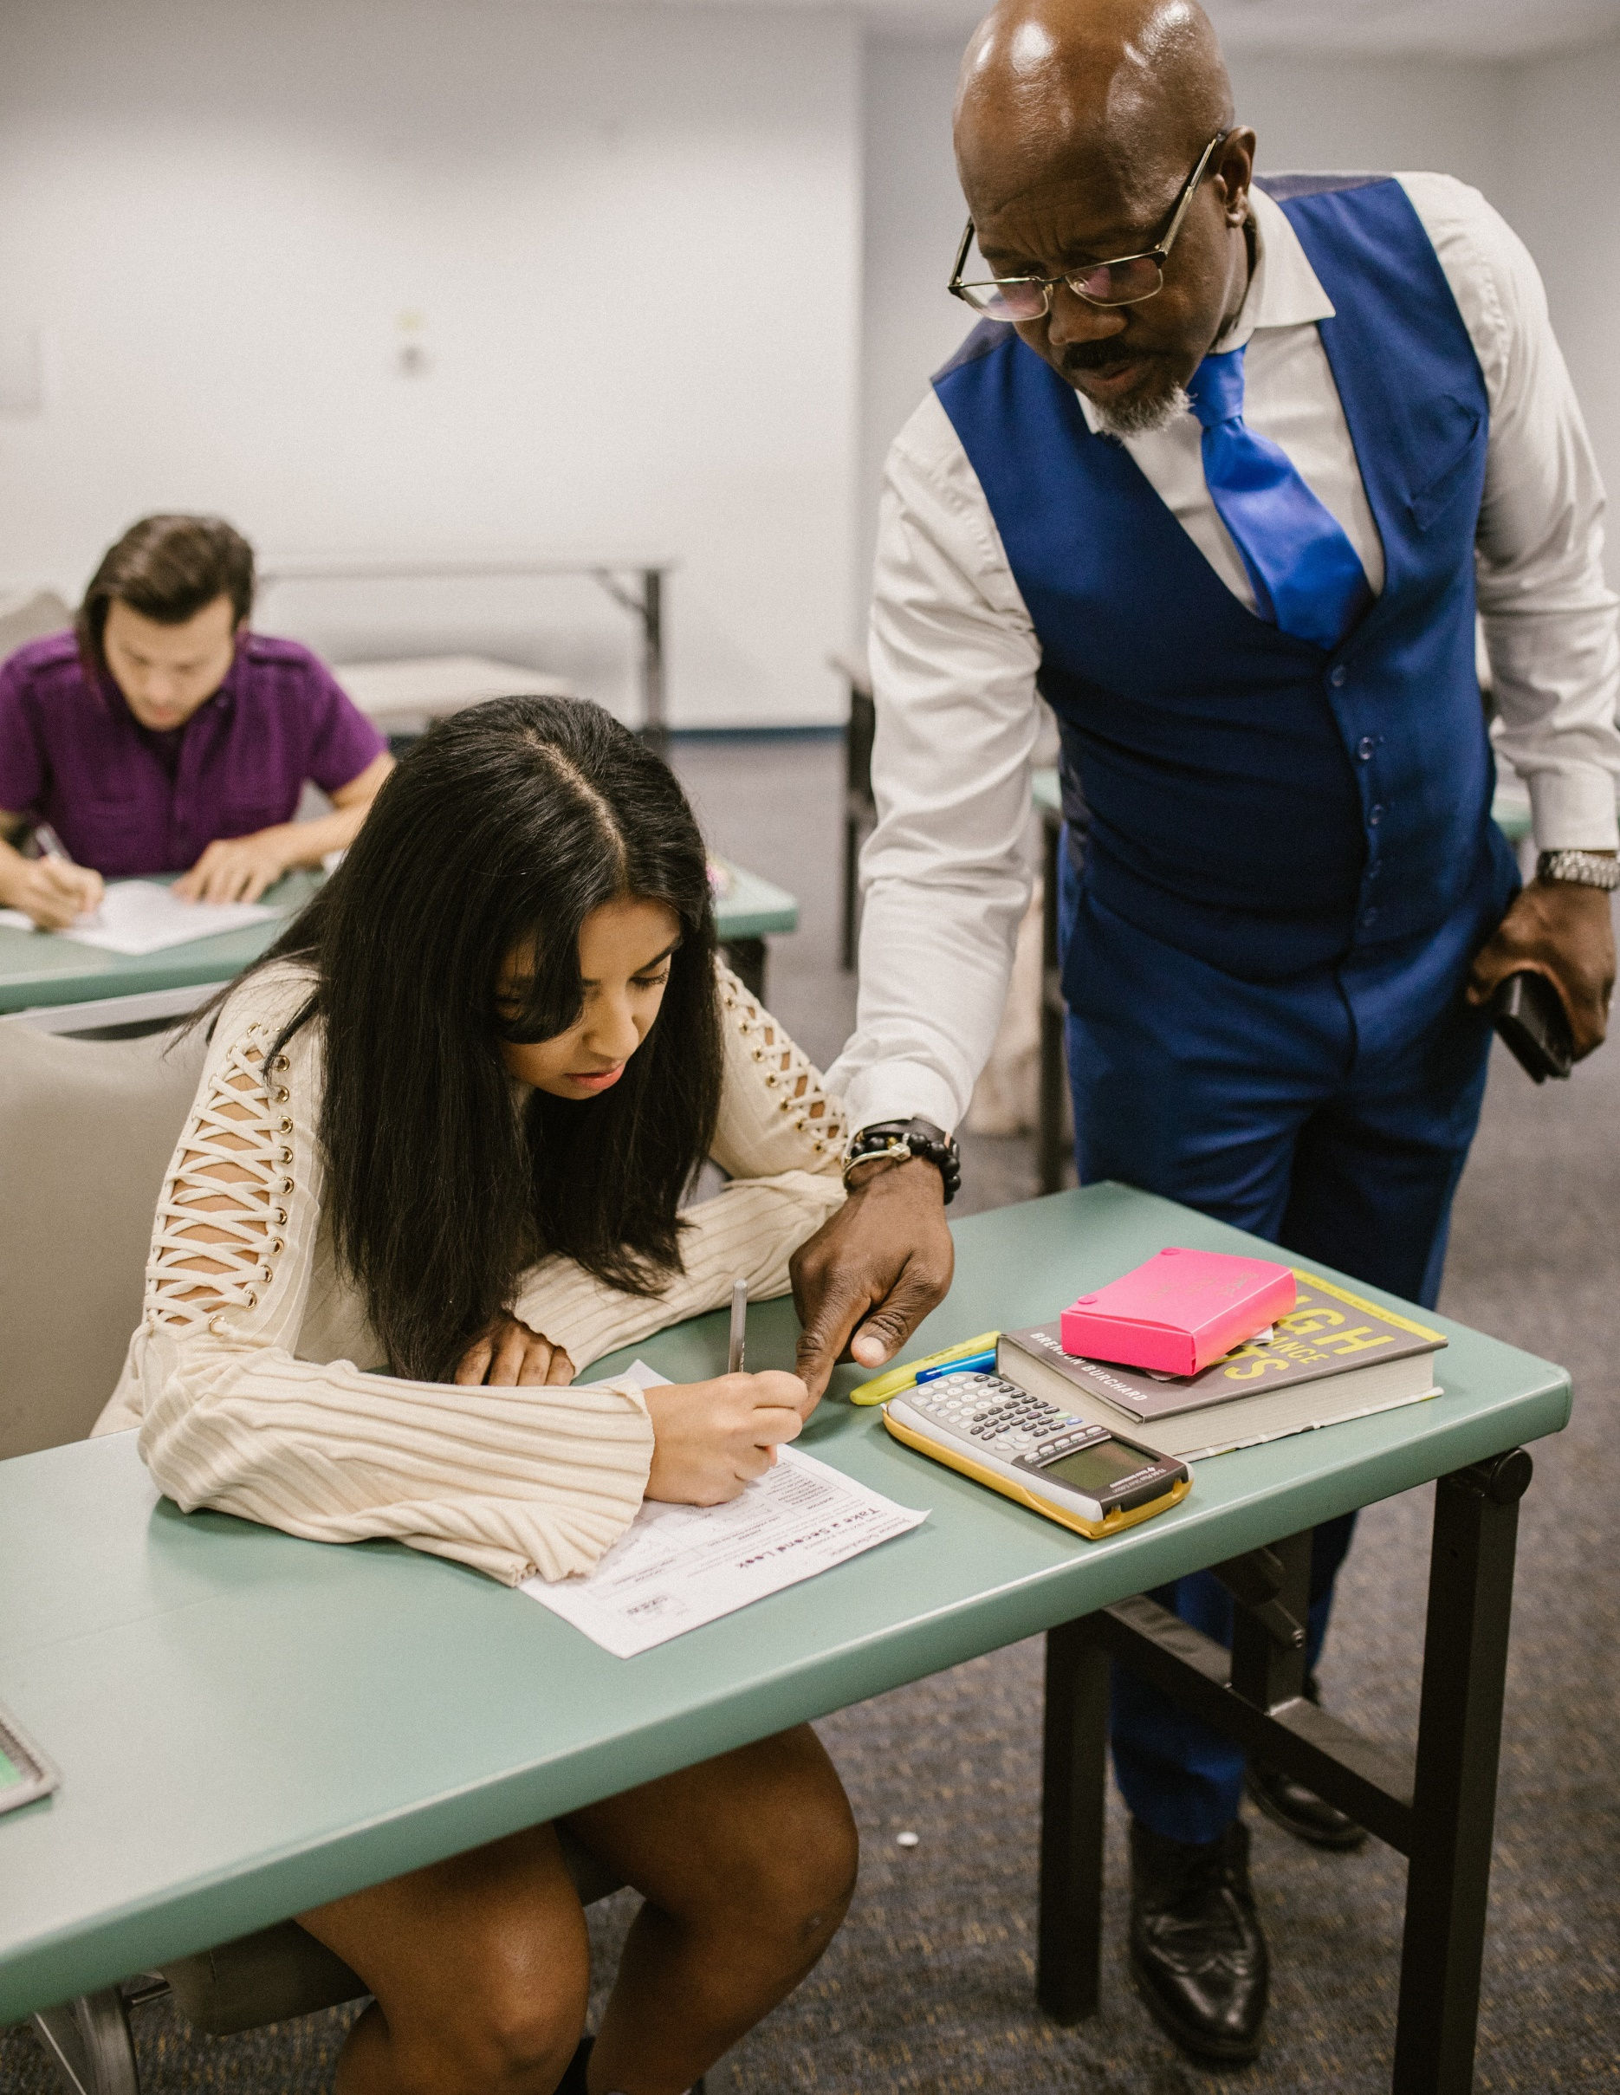

**Accessible Learning Services**

**Work Integrated Learning (WIL)**

**Guideline and Process**

# Table of Contents

Contents

Table of Contents 2

WIL Guideline and Process 3

Introduction 3

Key Partners 5

GBC Accessible Learning Staff Responsibilities 5

WIL Practitioner Responsibilities 5

Student Responsibilities 6

Host Organization (Work Site) Responsibilities 6

What is a WIL Accommodation Plan? 7

How to Request Accommodations Using the WIL Accommodation Template 7

WIL Accommodation Registration Process 8

WIL Self-Report Tool 9

A. Self-Report Functional Limitations Checklist 10

B. Self-Report Skills and Strengths Checklist 13

Additional Accommodation Planning Resource: Job Demands and Accommodation Planning Tool for Workers (JDAPT) 17

WIL Accommodation Plan Template 18

C. Disability Accommodation Request Template (sample) 19

Faculty Communication Support 20

Additional Support 21

# WIL Guideline and Process

## Introduction

Work-integrated learning (WIL) is a model and process of curricular experiential education, which formally and intentionally integrates a student’s academic studies within a workplace or practice setting.

Work-integrated learning is a type of experiential learning that combines a student’s academic studies with experiential learning in a workplace or practice setting. It generally involves a student, the college, and a host organization. They can include apprenticeships, campus entrepreneurship and incubators, co-op, field experiences, placements (field, clinical and practicum), and service learning.

WIL Practitioners at GBC can include: Co-op Advisors, Field Placement Coordinators/Officers, Student Liaisons, Liaison Coordinators.

George Brown College is committed to equal opportunity for students with disabilities and will make every effort to provide a barrier-free learning experience. Students with disabilities are expected to meet program and Work- Integrated Learning (WIL) requirements and are entitled to reasonable and appropriate accommodations, by the Ontario Human Rights Code and the Accessibility for Ontarians with Disabilities Act.

**Students are not required to disclose disability diagnoses to access accommodations.**

Students requiring accommodations in a WIL setting can be supported by an Accessibility Consultant and WIL Practitioner.

**Please note that the George Brown College Accommodation Plan applies to your academic courses on-campus and does not apply to WIL.** The following guidelines and accompanying form outline the process for accessing WIL accommodations.

# Key Partners

There are key partners involved in the creation of the WIL Accommodation Plan.

## GBC Accessible Learning Staff Responsibilities

* Accessibility Consultant (AC) works collaboratively with the student and WIL practitioner to identify the functional limitations/barriers in the WIL environment.
* AC will share WIL Accommodation Student Toolkit and WIL Self-Report Tool with students before meeting for the WIL intake.
* AC may also consult the WIL practitioner for guidance on program-specific outcomes in placement to determine the most appropriate recommendations.
* AC determines reasonable and appropriate WIL accommodations for students with disabilities through collaboration with the student, academic program, and WIL practitioners and the host organization.

## WIL Practitioner Responsibilities

* WIL Practitioners can include: Co-op Advisor, Field Placement Coordinators/ Officers, Student Liaisons, Liaison Coordinators.
* Update WIL platforms (i.e., D2L, field placement manuals) with WIL Accommodation Guidelines and Self-Report Tool.
* Remind students to connect with Accessible Learning Services (before the WIL term) to review the option of accessing accommodations in WIL.
* Reassure students that accessing accommodations will not change how the employer views them or diminish their value.
* Provide students with skills list, job description/requirements for AC accommodation meeting.
* Work collaboratively with the student, AC, academic program, and the host organization to determine possible WIL accommodations.
* Support to participate in conversations about their disability-related needs and limitations with their host organization as needed.

## Student Responsibilities

* Schedule a meeting with AC to discuss WIL accommodations before the start of the WIL term (e.g., at least two months or the semester before to allow time to complete steps listed below).
* Provide appropriate documentation if required.
* Bring WIL term requirements and/or have knowledge of the program (e.g., skills list, job description) to meeting with AC.
* If able, review and complete a fillable copy of WIL Accommodation Self-Report Tool.
* Inform WIL Practitioner of accommodation needs in WIL setting.
* Inform host (work site) organization of accommodation needs.
* Send a copy of completed WIL Accommodation Plan to your WIL practitioner and WIL Supervisor at the start of the WIL term.
* Participate in discussions and provide ongoing feedback about accommodation needs during WIL term.
* Contact your AC prior to each WIL to update and send out WIL accommodations.

## Host Organization (Work Site) Responsibilities

* Review and implement requests for accommodation in good faith and in accordance with [Ontario Human Rights Code.](https://www.ohrc.on.ca/en/ontario-human-rights-code)
* Maintain the confidentiality of students accessing accommodations.
* Proactively communicate any concerns or issues with your student’s WIL Practitioner if anything arises during the WIL placement
* Collaborate with students and WIL Practitioners to implement accommodations that adhere to the principles of dignity, individualization, inclusion, and full participation.

# What is a WIL Accommodation Plan?

The WIL Accommodation Plan is completed by the student with guidance from their Accessibility Consultant and in consultation with their WIL Practitioner and academic program, if applicable.

The WIL Accommodation Plan:

* Is a communication tool that you and/or your WIL Practitioner can share with anyone involved with your WIL activity.
* Provides a structured, strengths-based approach to discussing accommodation needs.
* Facilitates the collaboration between the student, WIL Practitioner, and the host organization when planning for WIL accommodations.
* Your Accessibility Consultant (AC) will discuss how to access the WIL Accommodation Plan with you. Use of the form is ultimately your decision.

## How to Request Accommodations Using the WIL Accommodation Template

Note: Work-integrated learning (WIL) is a type of experiential learning and can include apprenticeships, campus entrepreneurship and incubators, co-op, field experiences, placements (field, clinical, and practicum), and service learning.

# WIL Accommodation Registration Process

1. The student should consult with WIL Practitioner and/or academic program about the requirements for successful completion of WIL term.
   * WIL Practitioners include: Co-op Advisors, Field Placement Coordinators/Officers, Student Liaisons, Liaison Coordinators
2. The student may want to complete the WIL Self-Report tool in advance of meeting with their AC, but it is not required.
   * This form is designed to help identify students’ strengths and skills as well as any disability-related accommodations needed for the WIL term.
3. The self-report tool is not shared with your WIL Practitioner.
4. If requested by the AC, provide disability-related documentation.
5. Work collaboratively with AC to complete each section of the WIL Accommodation Plan. Student to fill out the ‘Student Information’ section of the finalized WIL Accommodation Plan.
6. Work collaboratively with AC and WIL Practitioner to discuss when and how the WIL Accommodation Plan will be shared with host supervisor.
7. Consult with AC as needed over the WIL term.

**Note**: WIL accommodations do not automatically renew each term if you require renewal of accommodations, please consult with AC to manually renew them.

# WIL Self-Report Tool

Self-Report Functional Limitations Checklist and Self-Report Skills & Strengths Checklist are tools designed to help students reflect and engage in the process of developing their WIL accommodations. This tool can enable students to identify their strengths and limitations that would impact their WIL.

Students are encouraged to reflect and complete self-report tools prior to meeting with an Accessibility Consultant (AC) to develop their WIL accommodation plan. Additionally, this resource can be used by students who research and pick their own WIL.

# Self-Report Functional Limitations Checklist

**Symptoms of condition and/or medication(s)** which may affect WIL experience. (Check all that are relevant).

**COGNITION AND/OR BEHAVIOUR**

|  |  |  |  |  |
| --- | --- | --- | --- | --- |
| **Limitations** | **Mild** | **Moderate** | **Severe** | **Comments** |
| Attention/  Concentration |  |  |  | Click or tap here to enter text. |
| Memory |  |  |  | Click or tap here to enter text. |
| Time Management |  |  |  | Click or tap here to enter text. |
| Organization |  |  |  | Click or tap here to enter text. |
| Information Processing |  |  |  | Click or tap here to enter text. |
| Comprehension |  |  |  | Click or tap here to enter text. |
| Communication (verbal or written expression) |  |  |  | Click or tap here to enter text. |
| Stress Management |  |  |  | Click or tap here to enter text. |
| Social Interaction (e.g., teamwork) |  |  |  | Click or tap here to enter text. |
| Emotional Self-Regulation |  |  |  | Click or tap here to enter text. |

**Additional Comments:** Click or tap here to enter text.

**PHYSICAL**

|  |  |  |  |  |
| --- | --- | --- | --- | --- |
| **Limitations** | **Mild** | **Moderate** | **Severe** | **Comments** |
| Fatigue |  |  |  | Click or tap here to enter text. |
| Stair Climbing |  |  |  | Click or tap here to enter text. |
| Lifting/  Carrying/  Reaching |  |  |  | Click or tap here to enter text. |
| Gripping/  Grasping/  Dexterity |  |  |  | Click or tap here to enter text. |
| Mobility |  |  |  | Click or tap here to enter text. |
| Ability to Sit for a Sustained Period of Time |  |  |  | Click or tap here to enter text. |
| Ability to Stand for Sustained Periods |  |  |  | Click or tap here to enter text. |

**Additional Comments:** Click or tap here to enter text.

**SENSORY**

|  |  |  |  |  |
| --- | --- | --- | --- | --- |
| **Limitations** | **Mild** | **Moderate** | **Severe** | **Comments** |
| Vision |  |  |  | Click or tap here to enter text. |
| Hearing |  |  |  | Click or tap here to enter text. |
| Speech |  |  |  | Click or tap here to enter text. |

**Additional Comments:** Click or tap here to enter text.

# Self-Report Skills and Strengths Checklist

**Tasks or actions that you do well.** These traits and abilities are used to complete work, relate with others, and achieve goals. (Check all skills that are relevant).

**COMMUNICATION**

|  |  |  |  |  |
| --- | --- | --- | --- | --- |
| **Skills and Abilities** | **Minimal** | **Moderate** | **Strong** | **Comments** |
| Reading |  |  |  | Click or tap here to enter text. |
| Writing |  |  |  | Click or tap here to enter text. |
| Speaking |  |  |  | Click or tap here to enter text. |
| Listening |  |  |  | Click or tap here to enter text. |
| Presenting |  |  |  | Click or tap here to enter text. |
| Visual Literacy |  |  |  | Click or tap here to enter text. |

**NUMERACY**

|  |  |  |  |  |
| --- | --- | --- | --- | --- |
| **Skills and Abilities** | **Minimal** | **Moderate** | **Strong** | **Comments** |
| Understanding and Applying Mathematical Concepts and Reasoning |  |  |  | Click or tap here to enter text. |
| Analyzing and Using Numerical Data |  |  |  | Click or tap here to enter text. |
| Conceptualizing |  |  |  | Click or tap here to enter text. |

**CRITICAL THINKING AND PROBLEM SOLVING**

|  |  |  |  |  |
| --- | --- | --- | --- | --- |
| **Skills and Abilities** | **Minimal** | **Moderate** | **Strong** | **Comments** |
| Analyzing |  |  |  | Click or tap here to enter text. |
| Synthesizing |  |  |  | Click or tap here to enter text. |
| Evaluating |  |  |  | Click or tap here to enter text. |
| Decision Making |  |  |  | Click or tap here to enter text. |
| Creative and Innovative Thinking |  |  |  | Click or tap here to enter text. |

**INFORMATION MANAGEMENT**

|  |  |  |  |  |
| --- | --- | --- | --- | --- |
| **Skills and Abilities** | **Minimal** | **Moderate** | **Strong** | **Comments** |
| Teamwork |  |  |  | Click or tap here to enter text. |
| Relationship Management |  |  |  | Click or tap here to enter text. |
| Conflict Resolution |  |  |  | Click or tap here to enter text. |
| Leadership |  |  |  | Click or tap here to enter text. |
| Networking |  |  |  | Click or tap here to enter text. |
| Visual Literacy |  |  |  | Click or tap here to enter text. |

**PERSONAL**

|  |  |  |  |  |
| --- | --- | --- | --- | --- |
| **Skills and Abilities** | **Minimal** | **Moderate** | **Strong** | **Comments** |
| Managing Self |  |  |  | Click or tap here to enter text. |
| Managing Change, Being Flexible and Adaptable |  |  |  | Click or tap here to enter text. |
| Engaging in Reflective Practices |  |  |  | Click or tap here to enter text. |
| Demonstrating Personal Responsibility |  |  |  | Click or tap here to enter text. |

**Additional Comments and/or Recommendations:** Click or tap here to enter text.

# Additional Accommodation Planning Resource: Job Demands and Accommodation Planning Tool for Workers (JDAPT)

This supplementary tool students can use to help get a better understanding of their limitations and it provides examples of accommodations.

JDAPT is an easy-to-use online tool designed for workers with an episodic disability—that is, a chronic health condition, often invisible, that reoccurs, fluctuates or is getting worse over time. If that includes you, the JDAPT can help you identify the support you may need to continue working comfortably, safely and productively in your job.

[JDAPT for workers | ACED - Accommodating and Communicating about Episodic](https://aced.iwh.on.ca/jdapt/worker-en/access) [Disability (iwh.on.ca)](https://aced.iwh.on.ca/jdapt/worker-en/access)

Students can complete the JDAPT and share results with their Accessibility Consultant and use the recommendations from the JDAPT tool to build their WIL accommodations during their WIL appointment.

# WIL Accommodation Plan Template

**Student Name:** Click or tap here to enter text.

**Student Number:** Click or tap here to enter text.

**Program:**Click or tap here to enter text.

**WIL Practitioner:** Click or tap here to enter text.

**Contact Info:** Click or tap here to enter text.

**Date:** Click or tap here to enter text.

Use the information gathered from the above tools and complete the sections below

**Identified Strengths and Skills:** Click or tap here to enter text.

**Functional Impact of Disability:** Click or tap here to enter text.

**Strategies that have helped me:** Click or tap here to enter text.

**Suggested WIL Accommodations:** Click or tap here to enter text.

# C. Disability Accommodation Request Template (sample)

This can be used as a sample email to address your need for accommodations. This email should be accompanied by the completed WIL Accommodation Form.

Hello,

My name is Click or tap here to enter text.and my student number isClick or tap here to enter text.. I am taking this opportunity to share that I may require accommodations during my WIL term. I believe that my Click or tap here to enter text.**[list one or two strengths from Self-Report Skills and Strengths Checklist]** will allow me to excel in this position; however, sometimes Click or tap here to enter text. **[indicate your functional limitations from Self-Report Functional Limitations Checklist]** might impact my ability to **[describe the duties you may have difficulty performing - refer to job description]**. In the past, I have found that I can overcome this issue with Click or tap here to enter text. **[describe specific accommodations you need]**. I am hoping we can proactively discuss appropriate accommodations.

Disability Accommodation Request Example:

I am taking this opportunity to share that I may require accommodations. I believe that my time management skills and attention to detail will allow me to excel in this position; however, sometimes when I am in rooms where I can overhear conversations it might impact my ability to stay focused. In the past, I have found that I can overcome this issue with the use of earplugs or noise cancelling headphones. I am hoping we can proactively discuss appropriate accommodations.

# Faculty Communication Support

Not sure how to communicate with your students about accessing supports during their WIL term? Below is a template that can be incorporated into your placement manual, D2L or any other relevant location so students can learn about how to register for accommodations in their WIL if they have a disability or suspected disability.

Dear Students,

We recognize the importance of providing equal opportunities for all students, including those with disabilities, to thrive in their work-integrated learning (WIL) experiences. To ensure that students with disabilities receive the necessary accommodations during their WIL term, we have established a registration process.

Throughout your WIL term, feel free to consult with your AC as needed. Your AC is here to provide support and assistance with any accommodation-related concerns that may arise during your placement.

We are committed to promoting an inclusive and supportive environment for all students participating in work-integrated learning. If you have any questions or require further assistance regarding accommodations, please don't hesitate to reach out to your Accessibility Consultant or contact the Accessible Learning Services (ALS) office via [alsregister@georgebrown.ca](mailto:alsregister@georgebrown.ca).

# Additional Support

Plan and schedule follow-up discussions with host supervisor and/or WIL Practitioner, as necessary, to assess the effectiveness of accommodations. Contact AC and/or WIL Practitioner with any questions or concerns. Host Organizations are encouraged to contact the WIL Practitioner listed on the WIL Accommodation Form.

Contact AC and/or WIL Practitioner with any questions or concerns.

Host Organizations are encouraged to contact the WIL Practitioner listed on the WIL Accommodation Form if concerns arise.

You can also visit or contact Accessible Learning Services (ALS) Office:

* St James Campus room 582C [letstalk@georgebrown.ca](mailto:letstalkwf@georgebrown.ca).
* Casa Loma Campus room CL 317C [letstalkcl@georgebrown.ca](mailto:letstalkcl@georgebrown.ca).
* Waterfront Campus room 225 [letstalkwf@georgebrown.ca](mailto:letstalkwf@georgebrown.ca).